**Chapter 6 Exercises (Advanced)**

(This exercise uses the tables and models created in chapter 4 & 5 exercise)

1. **Create Backend Configuration**

At Magento Backend Configuration section:

* Create a tab named “Magenest”
* Create a sub-tab in “Magenest” named “Movie”

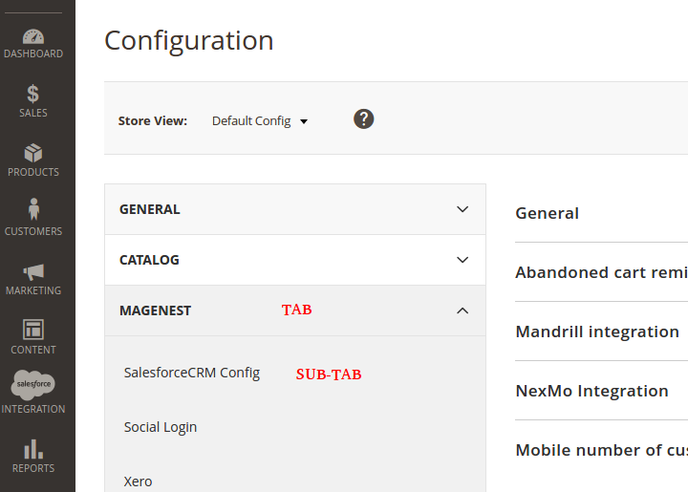

* Create these fields in sub-tab’s content section

|  |  |  |
| --- | --- | --- |
| Label (exact characters) | Type | Extra |
| Text Field | Text |  |
| Yes/No_Field_abcd | Yes/No (use Magento\Config\Model\Config\Source\Yesno) | *Notice the color |
| Custom Select Field | Select | This field’s select options is defined as: (label => value)   * “show” => 1 * ”not-show” => 2 |
| Rows in table “magenest_movie” | Text | This field’s value is equal to number of rows in table “magenest_movie”, read-only |
| Rows in table  “magenest_actor” | Text | This field’s value is equal to number of rows in table “magenest_actor” AND this field is only visible if “Custom Select Field” ‘s value is “show”, read-only |
| Button Field | Button | When click on this button, reload page. |

* Create default value for these fields (Field => Value, research file etc/config.xml)
  + “Text Field” => “I’m a text field”
  + “Yes/No_Field_abcd” => “Yes”
  + “Custom Select Field” => 1

**2. Create Data Grid for tables.**

At Magento Backend

* Create Data Grid for table “magenest_movie”, “magenest_director”, “magenest_actor” (create a new page for each grid), e.g of a grid:

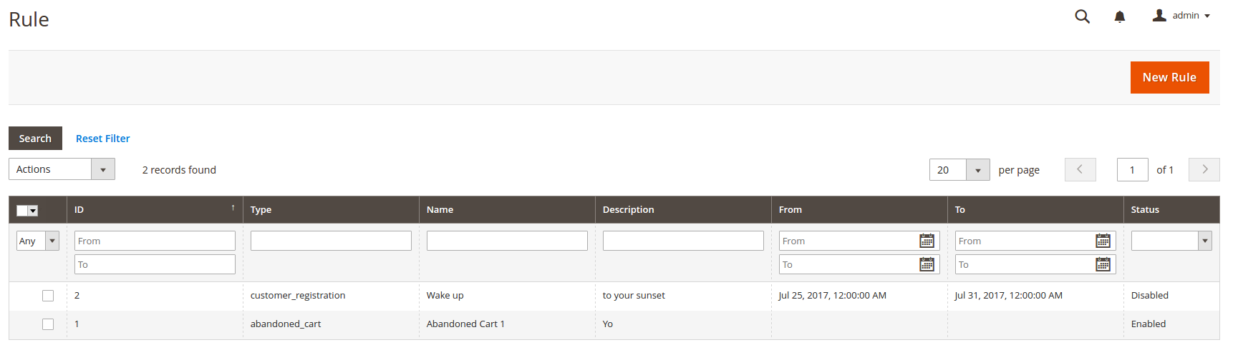

* Add a button called, “New Movie” (same as “New Rule” in the picture above)
  + When clicked, redirect user to a new page to Create a new movie.
  + Create a new page to add new movie, the page contain form with all fields (in table “magenest_movie”) of a movie.
  + Handle inputted data and save a new movie.
* Create a new Menu Item named “Movie”
  + Create Movie’s sub-items (for each tables), link these items to grid pages.

